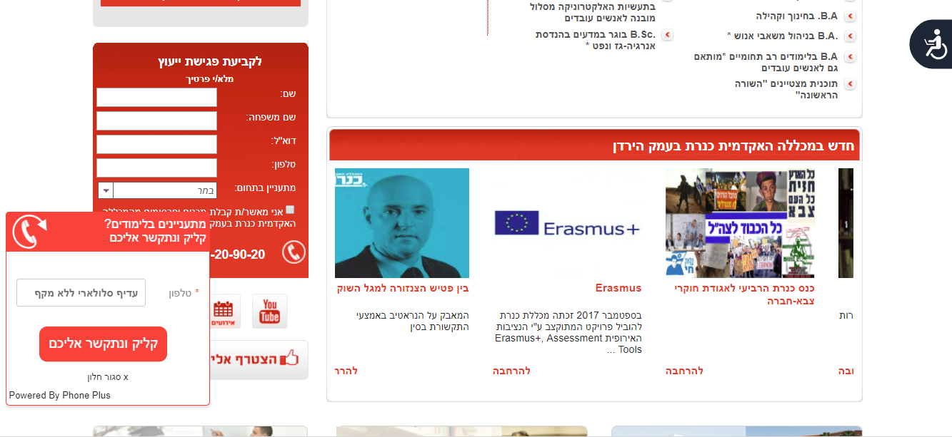

Information in HEBREW:
http://www.kinneret.ac.il/Web/ResearchInstitutes/raki/rscpr/Erasmus/Default.aspx
Information in ENGLISH:
http://www.kinneret.ac.il/Web/En/ResearchCenters/rp/Default.aspx

