WELCOME to GORDON ACADEMIC COLLEGE OF EDUCATION

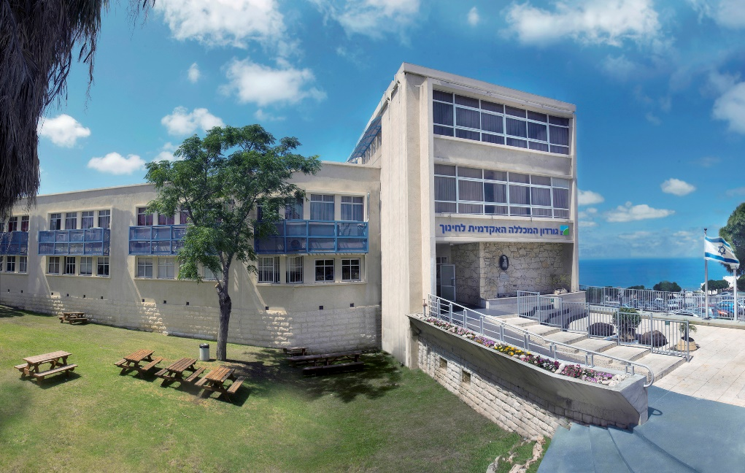
Gordon Academic College of Education (GACE) welcomes you and hopes your stay in Haifa will be enjoyable and fruitful. This brochure is addressed to academic and administrative staff who visit GACE within the framework of the Erasmus+ exchange and mobility programme. This guide is to help you with practical matters concerning your visit including travel arrangements, accommodation, organizing your academic programme, etc.

We hope that our assistance will help you deal with all the matters related to your visit as smoothly as possible. Should you have any questions or need additional information, please do not hesitate to contact us at any time!

We are looking forward to meeting you in Haifa. International Center, Gordon Academic College of Education, 73 Tchernichovsky street, Haifa, 3570503, Israel.

Before coming to Gordon Academic College

Please check whether you are required to have a visa to Israel. If you need a letter of invitation, we will send it to you as soon as you are accepted to carry out the mobility.

Arrival

The fastest and most reliable form of transportation from Ben Gurion Airport to Haifa is the train.
The train station is at a very convenient location, next to the Arrivals Hall, with access to the station (just follow the signs to the train station). Ben Gurion Airport station is on the Tel Aviv to Modiin train line and access is easy by train to many parts of the country, especially Tel Aviv and Haifa. A train service is available from Ben-Gurion Airport, day and night*. Information can be found at Israel-Railways web site: http://www.rail.co.il/EN/Pages/HomePage.aspx under “Schedules and Fares”. From station: “Ben Gurion Airport”, To station: “Hof Ha-Carmel” (first station in Haifa).

Also at the airport are licensed communal taxis which can carry up to 10 people to different locations. They operate from the taxi stand outside the arrivals hall at Terminal 3. This taxi or van service (called 'sherut') departs whenever the car fills up, and takes you to Haifa for a reasonable rate of 110NIS ($30). Van service to Haifa or to Ben-Gurion Airport is provided by a company called "Amal" (Tel. 04-8662324 - 04-8676444) Taxies should fill up fairly quickly. The travel time is about an hour and a quarter. The driver will usually drop-off passengers where-ever they ask in Haifa, so asking a drop-off at the Hotel or Gordon Academic College is a good idea.

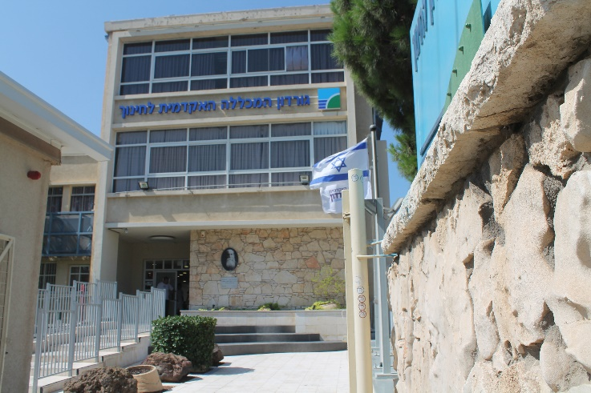
Private taxis from the airport to Haifa cost $100-150 but can be shared, and the price split, with a fellow participant. Prices may vary according to the time of day when you are arriving with night drives being more expensive than day drives. You can also rent a car. It is usually cheaper to arrange for cate rentals from your home country.

The bus is not very frequent and takes longer. The Egged bus company's website contains more details. (the bus company) lines can be found in English at http://www.egged.co.il/Eng/

* Please note that public transportation is not available from Friday afternoon until Saturday evening (SHABATH). Private taxis are available and charge a higher price for working during this time.

Insurance and health services
We strongly advise you to take out adequate travel insurance policy for the period of your stay in Israel. (most institutions insist that you must have travel insurance). Please make sure that you have a good travel insurance plan that will also cover possible medical expenses in Israel as well as emergency medical care. In case of emergency call 100 or 101.

Accommodation
As far as the accommodation is concerned, we recommend one of the following options:

Hotel's Name | Area | Hotel's Address | Website
Haifa Bay View Hotel | Carmel Center | 101 Hanassi Avenue, Haifa | www.haifabayviewhotel.com/
Dan Panorama Haifa Hotel | Carmel Center | 107 Hanassi Avenue, Haifa | www3.danhotels.com/HaifaHotels/DanPanoramaHaifaHotel
Dan Carmel Haifa Hotel | Carmel Center | 85-87 Hanassi Avenue, Haifa | www3.danhotels.com/HaifaHotels/DanCarmelHaifaHotel/Deals
Crowne Plaza Haifa | Carmel Center | 111 Yafe Nof St., Haifa | Crowne Plaza Haifa
Beth-Shalom hotel | Carmel center | HaNassi 110 , Haifa | www.beth-shalom.co.il
The Colony Hotel | Germen colony | 28 Ben Gurion Boulevard, Haifa | www.colonyhaifa.com
Leonardo Plaza Haifa | Beach | 10 David Elazar Street, Haifa | www.fattal-hotels.com/hotels_in_israel/haifa_hotels
Apartments all over the city |  |  | www.airbnb.com/s/Haifa--Israel

In addition our college has a special relationship with the Carmelite-Stella-Maris guest rooms http://www.travelujah.com/groups/entry/Carmelite-Stella-Maris. It is located opposite our college (5 minute walk). While individuals cannot make direct reservations, if you wish to stay there please contact us. Please be informed that this guest house has a 22:00 curfew.

Local transportation
Gordon Academic College is an urban campus located in the French Carmel in Haifa. The college is in a central location in Haifa, between the central Carmel and the coast. There is a breathtaking view from the college, which overlooks the slopes of the Carmel and the sea. Haifa is considered a friendly city both to its residents and the people visiting the city without a private vehicle. There are several means of public transportation which make it easier to move about the city as well as to and from it. Alongside many bus lines, special ‘neighborhood lines’ in several neighborhoods, taxi service and special taxis, Haifa has also the only underground funicular in the country. All these enable to reach each one of the city neighborhoods, each of the many attractions it has to offer, its splendid beaches, gardens, the museums that are scattered all around the city, the hotels, and so forth. More information on buses are available at https://www.bus.co.il/otobusimmvc/en
Taxi service in Haifa
Name | Tel
Merkaz Mizpe TAXI | 072-3310976
Hof Hacarmel TAXI | 072-2238297  04-8550055
Carmel TAXI | 072-3311536
Amal TAXI- to/from Ben-Gurion AIRPORT only | 04-8662324
Carmelit TAXI | 04-8664640
London TAXI | 04-8764484
Nave TAXI | 04-8222222
Kavey Hagalil TAXI | 04-8530303
Hamonitex TAXI | 04-8664343

Gordon Academic College of Education
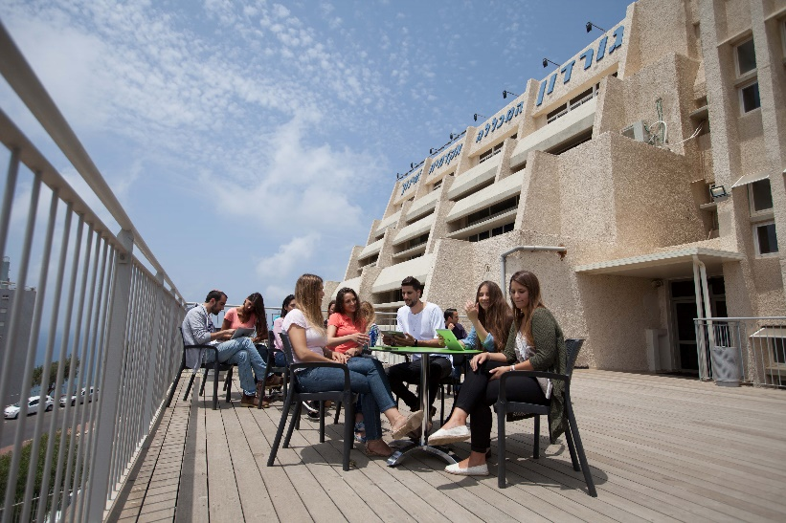
Gordon Academic College, established over 60 years ago, is an academic institution that trains students to be educators and teachers who are equipped to meet the educational and social challenges of the 21st century.
Located in the multicultural city of Haifa and its staff, students and faculty represent the many different cultural groups of this area. Jews, Druze, Arabs, religious, secular, Haredi, new immigrants and students with disabilities and special needs study and work at the college.
Gordon Academic College is one of the most advanced teacher colleges in the State of Israel integrating innovative pedagogy and methods in teaching and in learning. As a top college, we try to give every student the opportunity to maximize their potential and receive the skills and knowledge to be educational teachers and leaders in Israeli’s society.

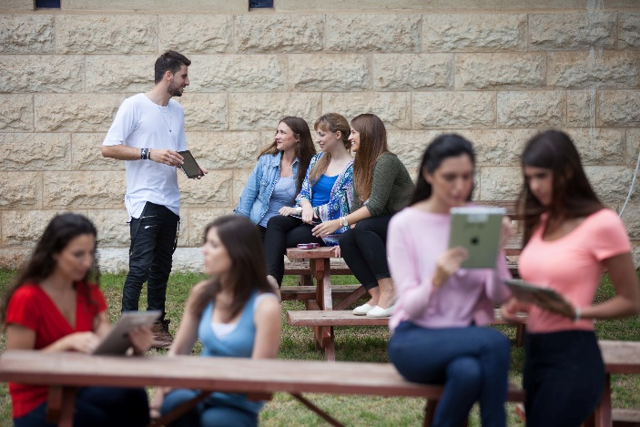
The academic teaching faculty of around 250 includes the country’s top professionals in education and research. They are renown not only within Israel but internationally and are active in participating in national and international conferences, research and educational projects.
Our student body numbers at about 4000 individuals come from all over Israel but we especially attract students from Haifa and the North. Many of our graduates hold key leadership positions in the education system.
As an academic college of education, Gordon Academic College is actively involved in community projects and each year, hundreds of our students as well as many of our faculty volunteer in the community and in special social programs aimed to make an important impact on those who benefit from these programs.

The following link provides greater detail into Gordon College’s programs and courses https://www.gordon.ac.il/English

The City of Haifa

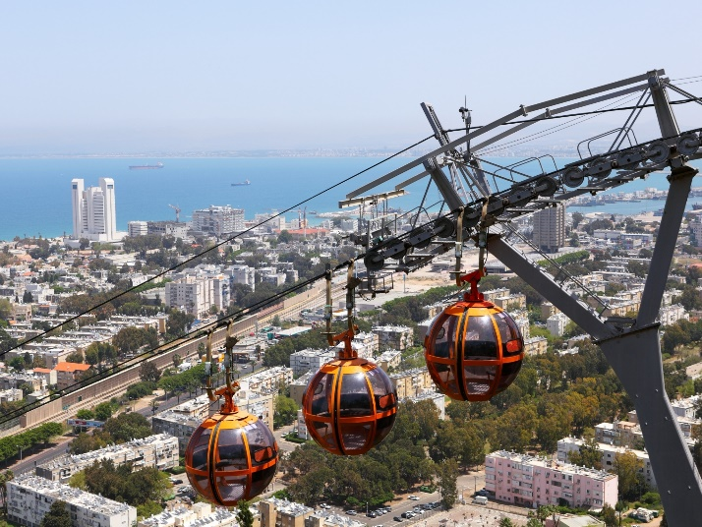
Haifa is the third-largest city in the State of Israel after Jerusalem and Tel Aviv, with a population of 278,900 in 2015. The city of Haifa forms part of the Haifa metropolitan area, the second- or third-most populous metropolitan area in Israel. It is also home to the Bahá'í World Centre, a UNESCO World Heritage Site and a destination for Baha'i pilgrims.
Built on the slopes of Mount Carmel, the settlement has a history spanning more than 3,000 years. The earliest known settlement in the vicinity was Tell Abu Hawam, a small port city established in the Late Bronze Age(14th century BCE). In the 3rd century CE, Haifa was known as a dye-making center.

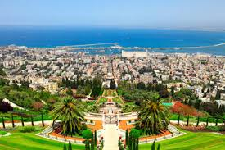
Over the centuries, the city has changed hands: being conquered and ruled by the Phoenicians, Persians, Hasmoneans, Romans, Byzantines, Arabs, Crusaders, Ottomans, British, and the Israelis. Since the establishment of the State of Israel in 1948, the Haifa Municipality has governed the city. As of 2016, the city is a major seaport located on Israel's Mediterranean coastline in the Bay of Haifa covering 63.7 square kilometres (24.6 sq mi). It lies about 90 kilometres (56 mi) north of Tel Aviv and is the major regional center of northern Israel. According to researcher J. Kis-Lev Haifa is considered a relative haven for coexistence between Jews and Arabs.
The city plays an important role in Israel's economy. It is home to Matam, one of the oldest and largest high-tech parks in the country. Haifa Bay is a center of heavy industry, petroleum refining and chemical processing.
There are several academic institutions of higher learning in Israel including the University of Haifa, the Technion, Gordon Academic College of Education as well as other specialized or technical institutions.

Weather
Haifa, Israel is at 32°49'N, 35°0'E, 10 m (33 ft). Haifa has a hot mediterranean/ dry-summer subtropical climate that is mild with moderate seasonality. Summers are dry and hot due to the domination of subtropical high pressure systems while winters experience moderate temperatures and changeable, rainy weather due to the polar front.

