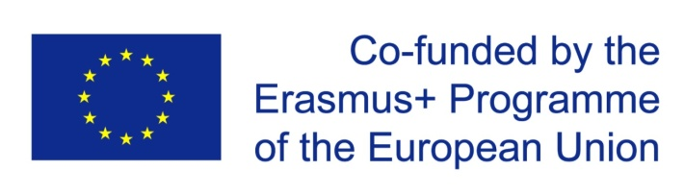

Request for changes in ______ISU GE P6_________
Equipment for ASSET:
ASSET Project number 585587-EPP-1-2017-1-IL-EPPKA2-CBHE-JP

 | Items in the original proposal | Cost | Changes  (specify the change, if no change is needed - write "no change") | Cost | Contribution of changes for program
1 | Smart board/projector | 2,900.00 € | No change | 2,900.00 €
2 | Simulation Lab with computers, video cameras and software for programs | 25,000.00 € | See Annex 1 – Portable lab | 25,000.00 € | Portable lab See Annex 2 – detailed justification ISU
3 | Dell Inspirion 5567 | 1,255.00 € | No change | 1,255.00 €
4
5
6
7
TOTAL | The original budget for equipment  ___29,155.00 € ______ |  | The revised budget  ____ 29,155.00 € _*__

- The price will be reduced during the tendering and will not exceed 29,155.Euros in total

