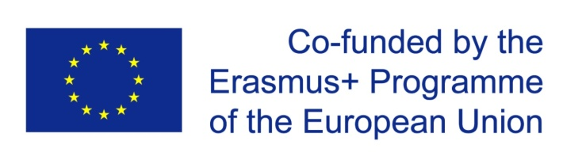

 | DISSEMINATION & EXPLOITATION  15-10-2017 - 15-10-2020  LEAD: HAC assisted by KCJV, VARAM and NTCPD  All partner HEIs | WP 4
Title | Dissemination and Exploitation of ASSET project
Description | GOALS:  - The visibility of the project will be enhanced by a distinctive project Website.  - Info and summaries of activities and results will also be available in English.  - Brochures, flyers, posters will be printed and spread to target groups as well.  - Promotion through network of practitioners  - Several sessions will take place during the three years of project.  - Project results will be presented to all stakeholders  - The steering committee will monitor and evaluate the realization of this WP while the Quality control Team will control quality of results.  - The dissemination team will elaborate promotional materials and handbooks and their distribution to all partners and other stakeholders.

Tasks and Deliverables

Task | Deliverables | Due date
4.1 Dissemination within ASSETS Consortium and online and social-Professional Networking | - Dissemination through internal meetings, seminars and workshops. Likewise, online and socio-professional networking. | 14-10-2020
4.2 Dissemination through ASSET’s Website | - KCJV will develop a project website where activities and announcement on course assessment developments undertaken during the project will be posted there.  - The non-educational organisations (VARAM and NTCPD) will provide significant press and publicity work in favour of the project | 14-10-2020
4.3 Dissemination to other HEIs and multiplier workshops and faculty training in IL and GE by partner NGOs | - During the second and third year, partner country HEIs will organise workshops and open days dedicated to invite faculty staff from other HEIs not directly involved in the project and present them with the project activities and results on CATs and impact on student performance | 14-10-2020
4.4 Participation and/or Organization of round tables, symposiums, national and international conferences in IL and GE | - At least 3 round tables/symposia/paper/poster presentations in conferences will occur during the second and third year.  - Whenever possible national project management meetings will coincide with these events. | 14-10-2020
4.5 Elaboration of handbooks with best practices and lessons learned from the project | - The complete project will be disseminated in a report containing best practices from project implementation, assessment results, recommendations and suggestions.  - They will be printed and distributed free of charge at the end of the project and available online. | 14-10-2020
4.6 Final Consortium Meeting and International Conference for Worldwide dissemination | - A final dissemination event will take place in Jerusalem.  - The impact of course assessment and other thematic areas in teaching/learning processes will be covered during the Conference. | 30-08-2020

