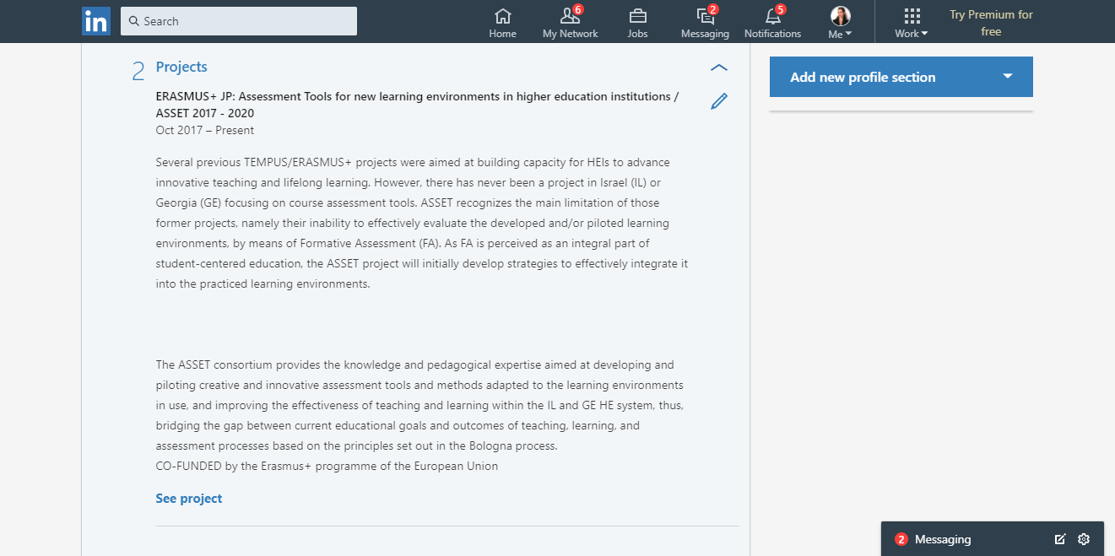
link: https://www.linkedin.com/in/dorit-alt-379673144/

