User Manual

ASSET

Train the trainer - GE

Contents
1) What is Mindomo 1
2) Registration guide 2
3) Function and operation for „concept map“ 5
3.1 How to create a concept map 5
3.2 How to configure a concept map 6
3.3 Additional features 11
3.4 Download 14
4) License conditions 15
4.1 Desktop License overview 15
4.2 Online License overview 15
5) Technical requirements 16

1) What is Mindomo
Mindomo is the best visual all-in-one solution for your lesson combining mind mapping, concept mapping and outline. As students begin to create mind maps, concept maps or outlines, they learn how to do things like brainstorm, synthetic and analytical thinking, questions, ideation, problem solving and research learning. Mindomo is also at the forefront of developing features such as transforming a concept map into a presentation and creating concept maps - the easiest way for teachers and students to work with concept maps, intelligent concept maps- partially completed templates, they allow beginners to get started quickly with concept maps and, of course, create maps from concept maps in real time. All of this helps students and teachers develop the capacity for research learning and teaching. Mindomo has both a Freemium online solution and free mobile apps for iPad and Android.

2) Registration guide
- Go to https://www.mindomo.com/
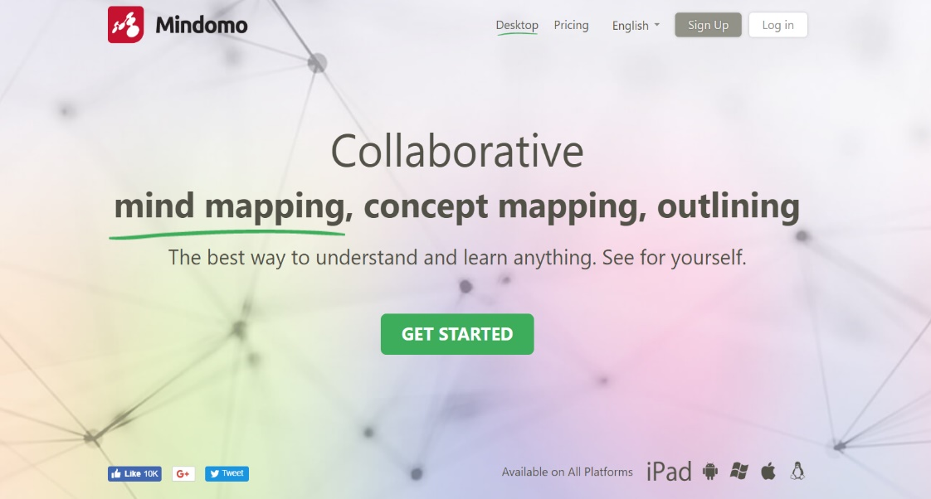
- Click on SignUp

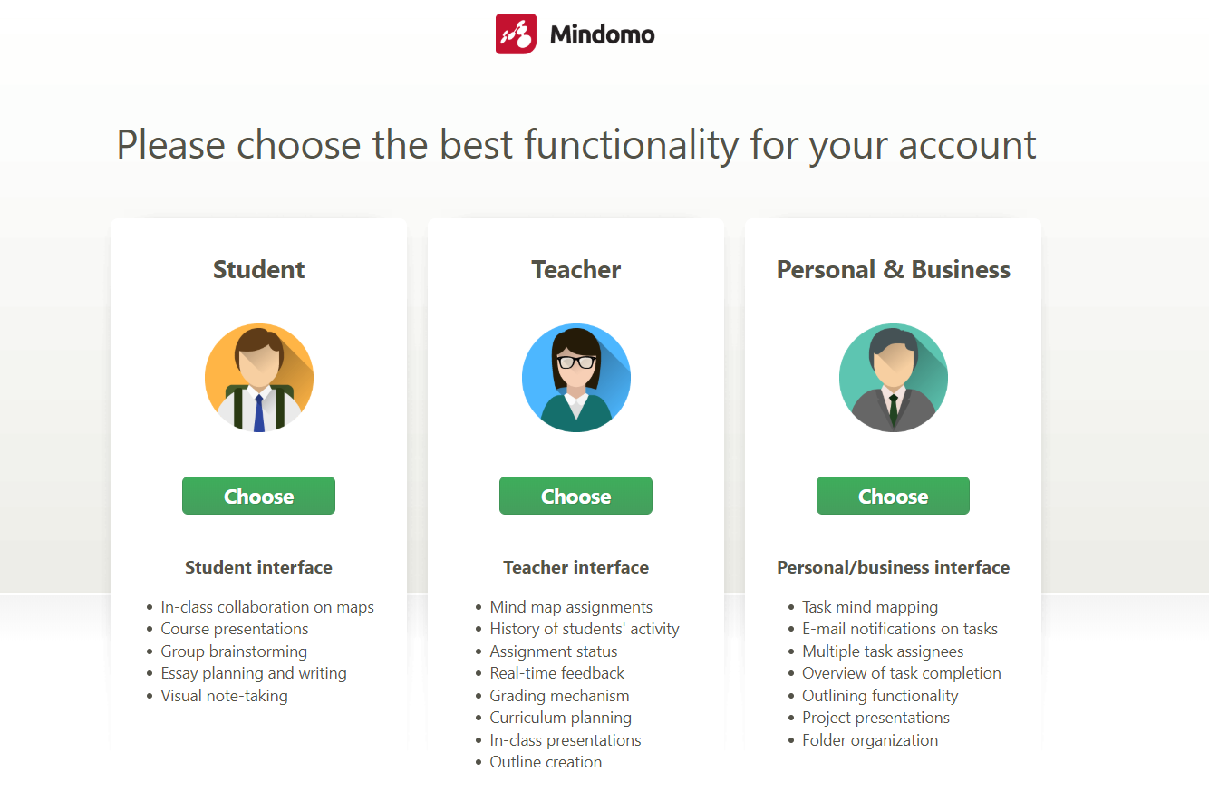
- Choose „Teacher“

- Enter your first and last name, your email-address and your individually password
Click the button I´m not a robot, agree the terms of use and privacy policy and sign up
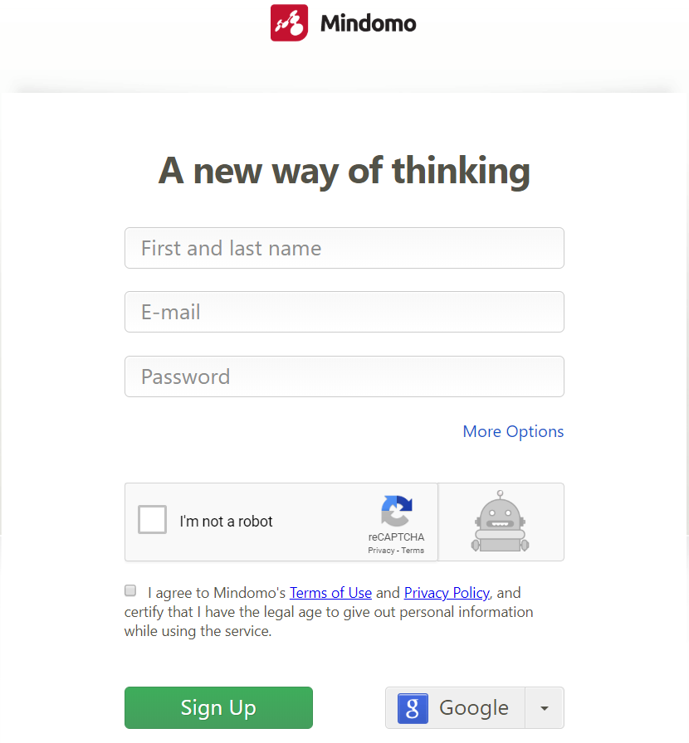

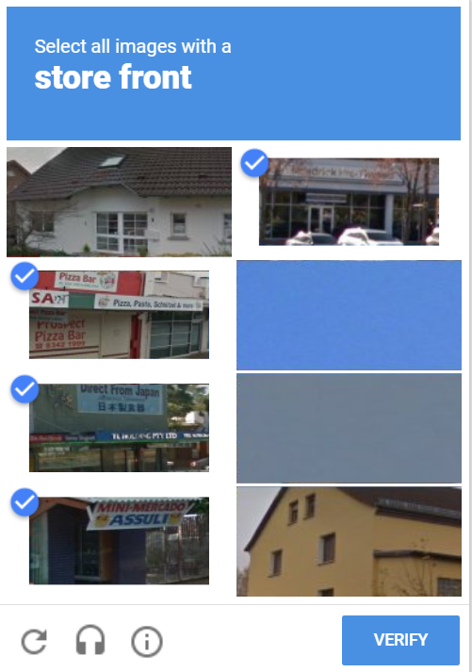
- Answer a question like this and verify

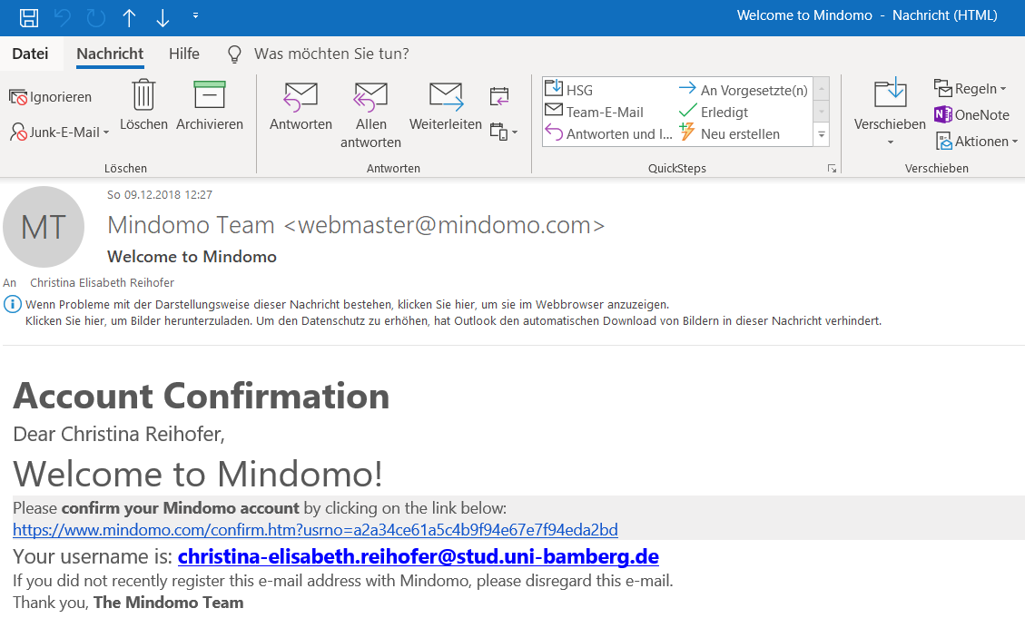
- Check your e-mail-account for the activation link (e-mail you entered before) and cklick on the link below

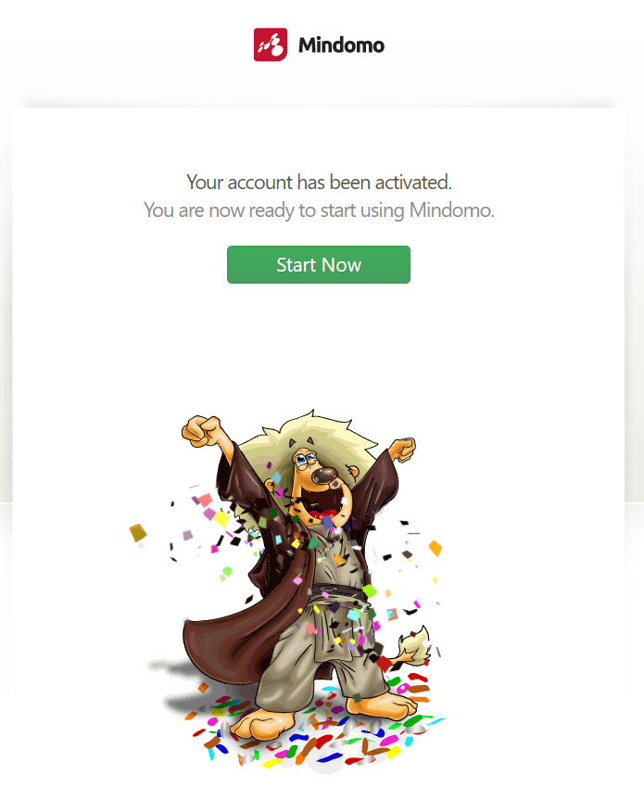
- You are now ready to start using Mindomo – start now

3) Function and operation for „concept map“

3.1 How to create a concept map

- Click on Create
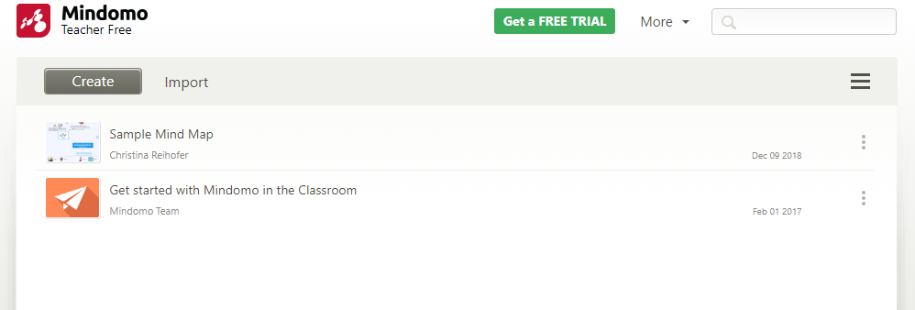

- Choose Blank Concept Map, enter a title and click on Create
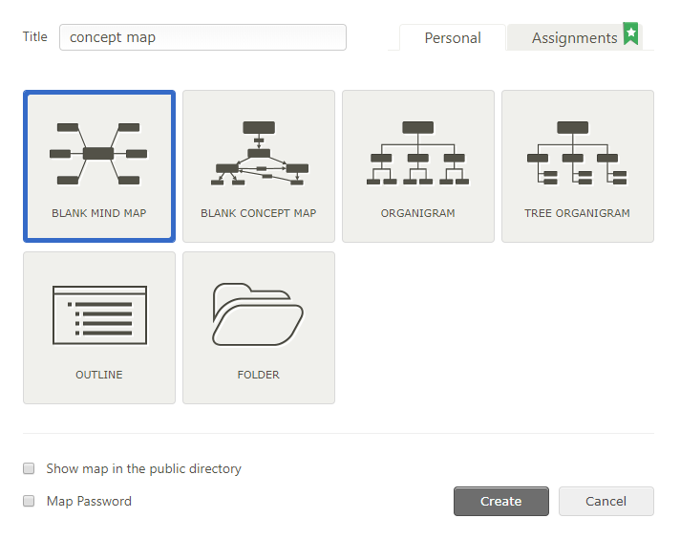

3.2 How to configure a concept map
- You can click on your concept map and configure it:
- Choose the font, the font size and the colour of your concept map
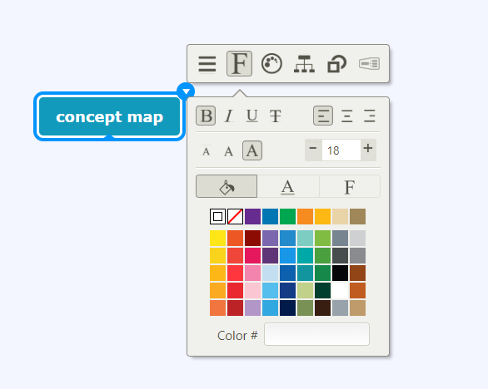

- Choose the style of your concept map
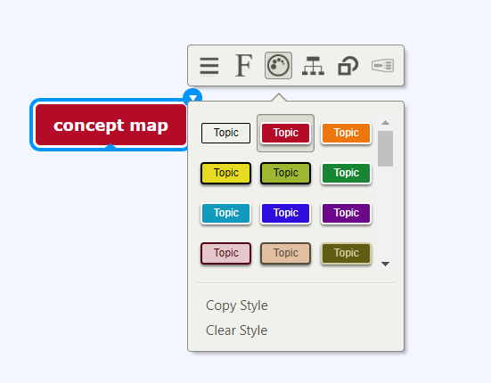

- Choose the subtopics position
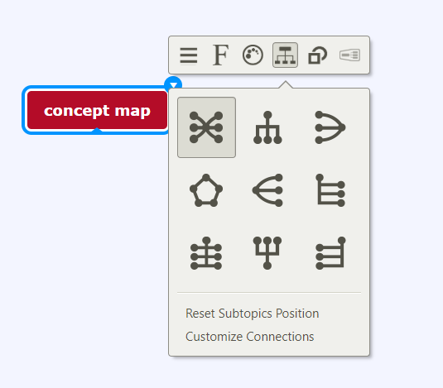

- Choose the form of your concept map
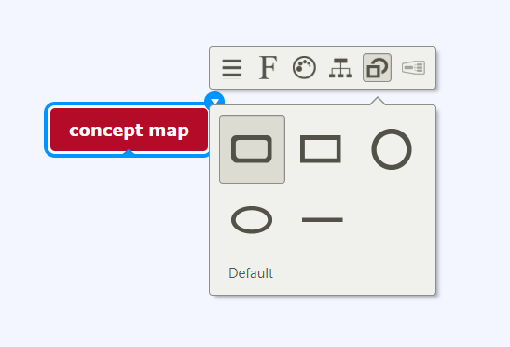

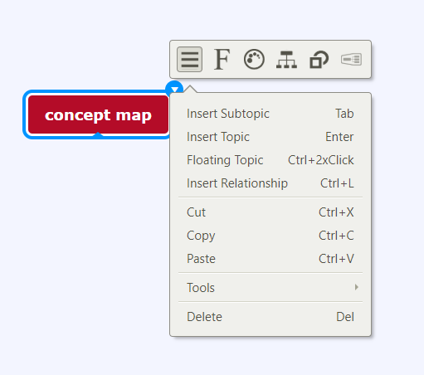
- You can insert new positions:

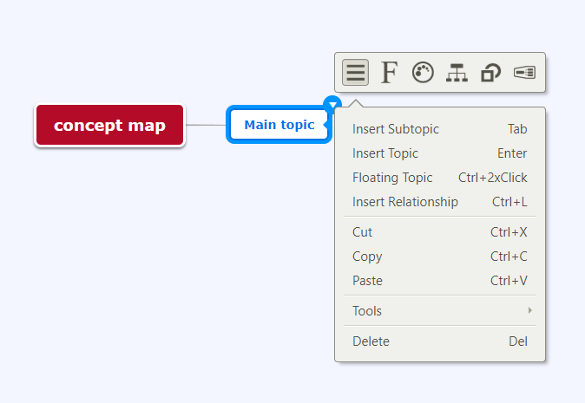
- Insert a topic and give it a name; configure your main topic the same way as the concept map see above (point 1)

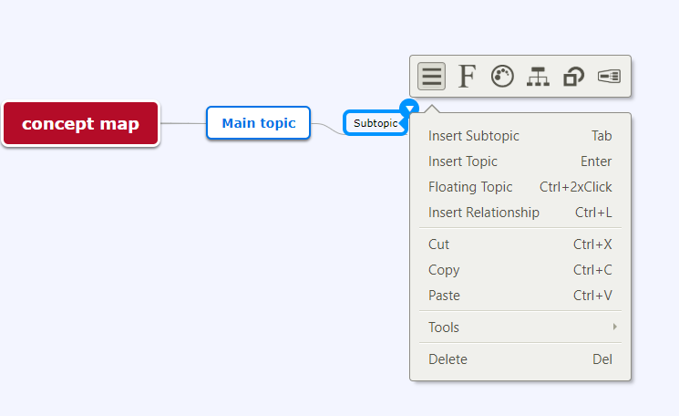
- Insert a subtopic and give a name to it; configure your subtopic the same way as the concept map see above (point 1)

- Insert a floating topic everywhere you want by clicking the right mousekey an choosing insert floating topic; configure your floating topic the same way as the concept map see above (point 1)
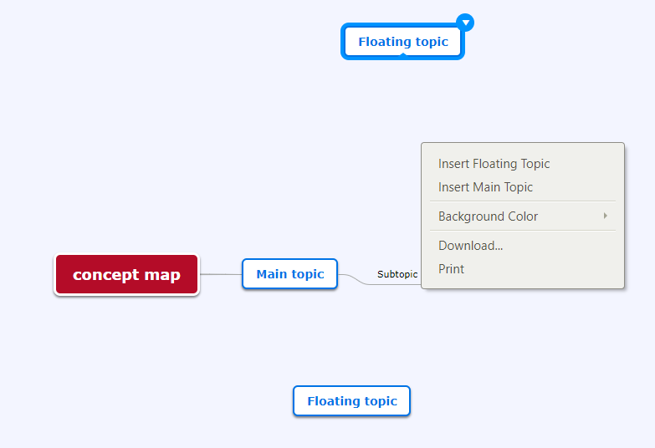

- You can insert a relationship between two topics: Click the right mousekey and choose Insert Relationship
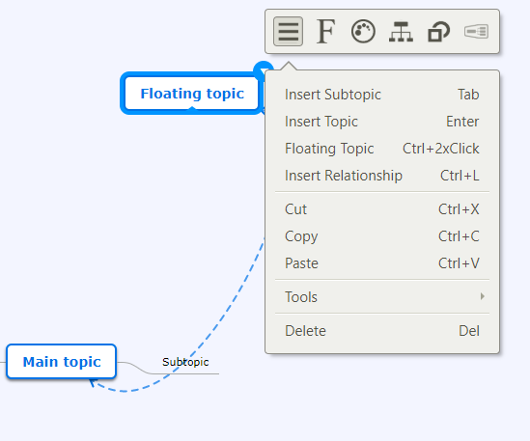

You can click on your relationship-line and configure it:
- Choose the colour of your relationship line
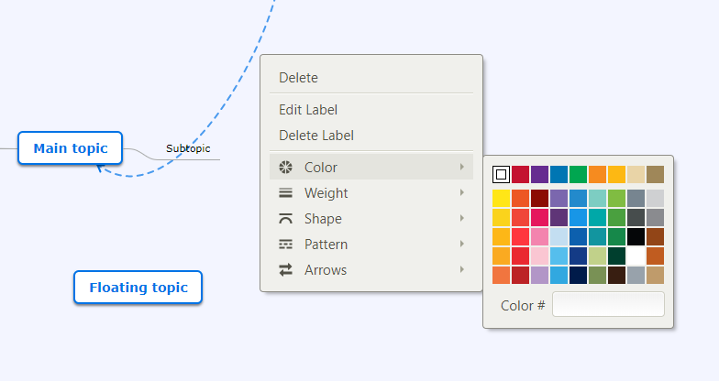

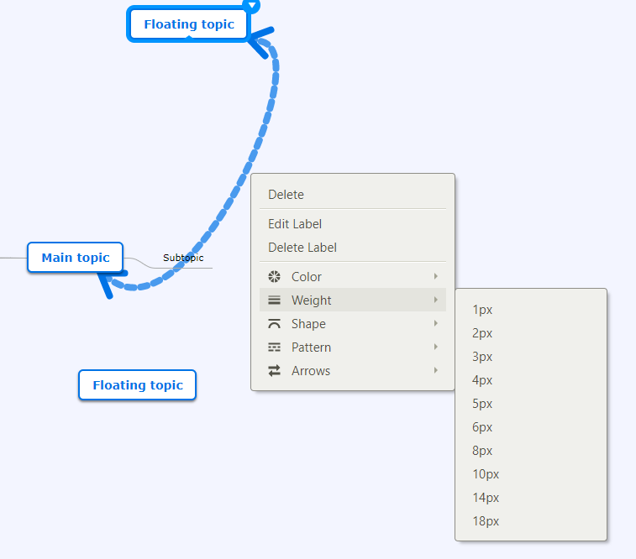
- Choose the weight of your relationship line

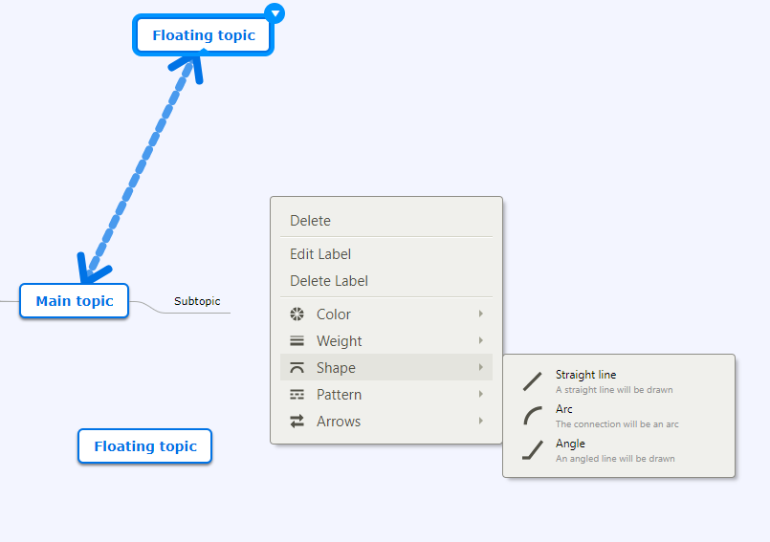
- Choose the shape of your relationship line

- Choose the pattern of your relationship line
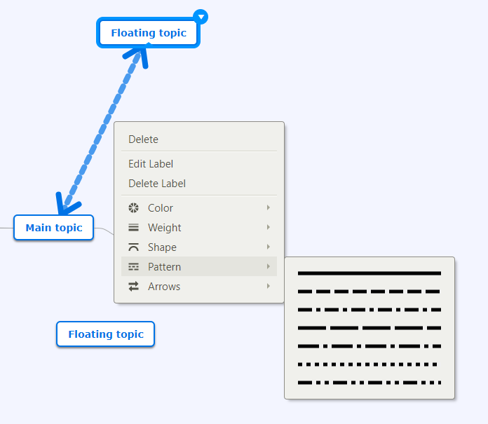

- Choose the arrows of your relationship line
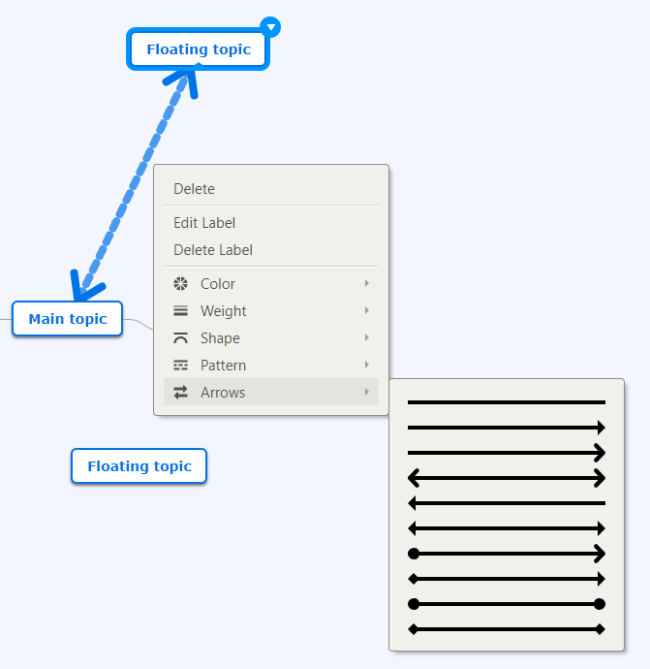

3.3 Additional features
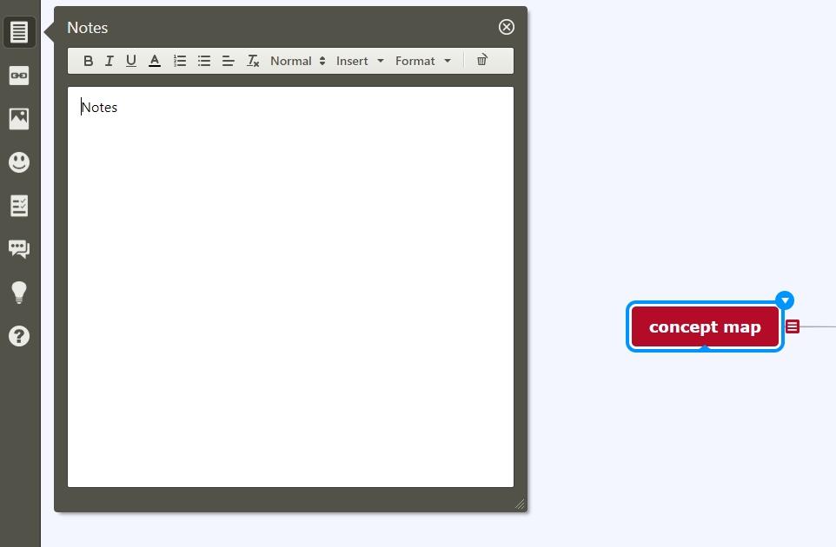
- You can insert notes at each topic, subtopic and floating topic

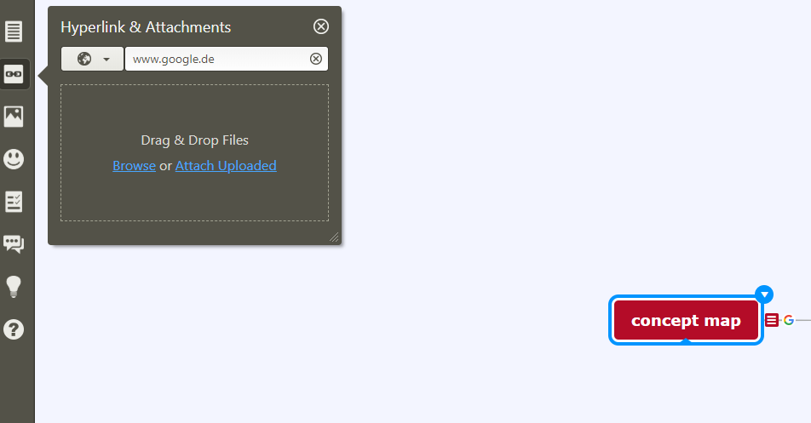
- You can insert hyperlinks at each topic, subtopic and floating topic

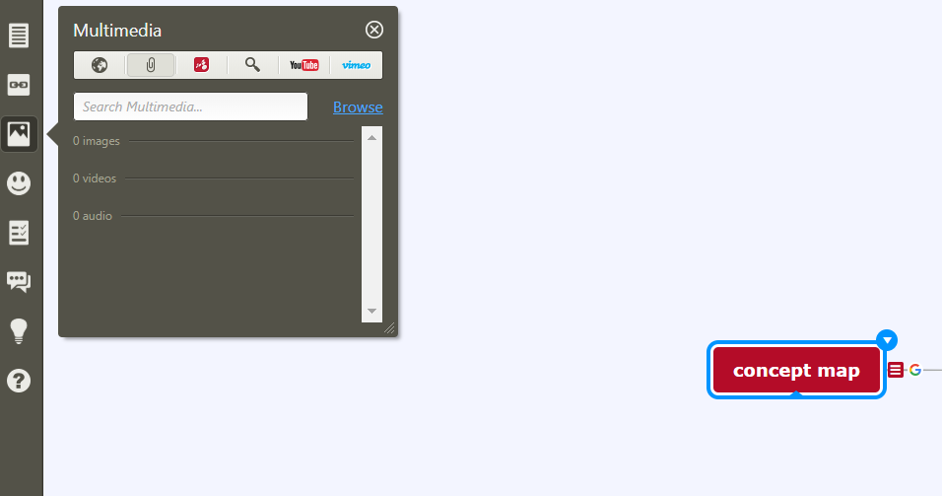
- You can insert multimedia at each topic, subtopic and floating topic Note: Only available for premium users

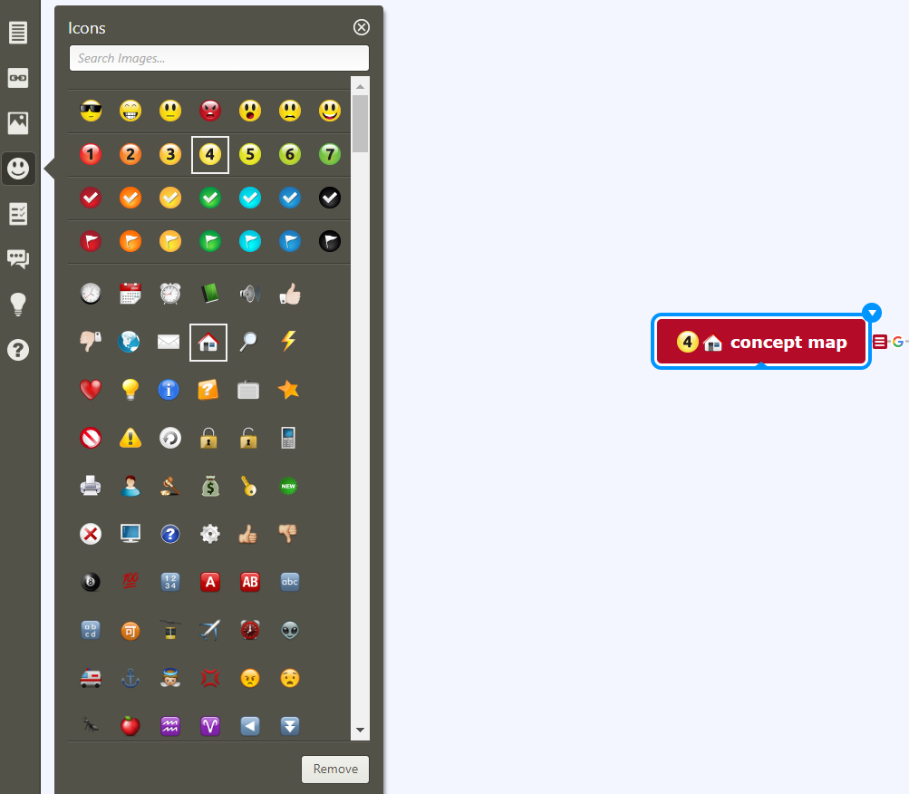
- You can insert icons at each topic, subtopic and floating topic

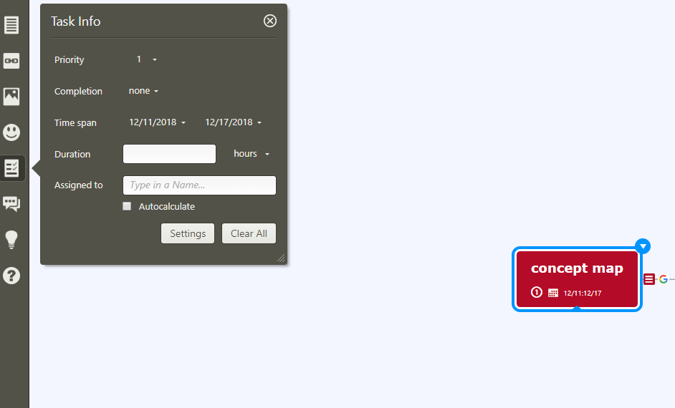
- You can insert a task information

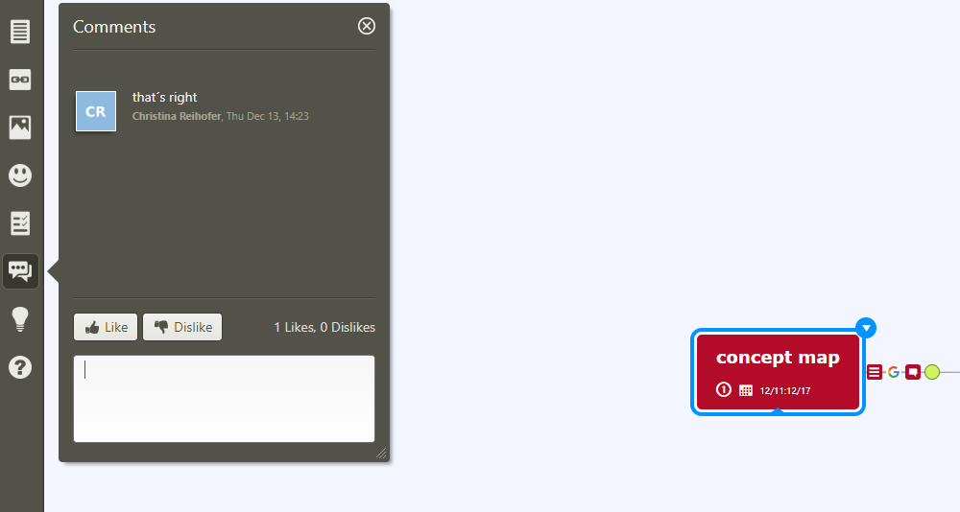
- 6) You can insert comments and give a like (green icon) or a dislike (red icon)

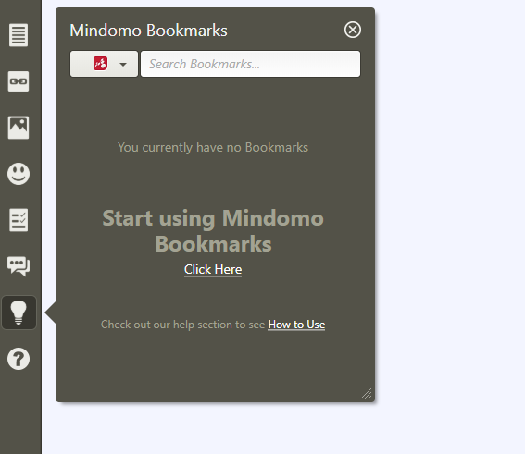
- You can insert bookmarks

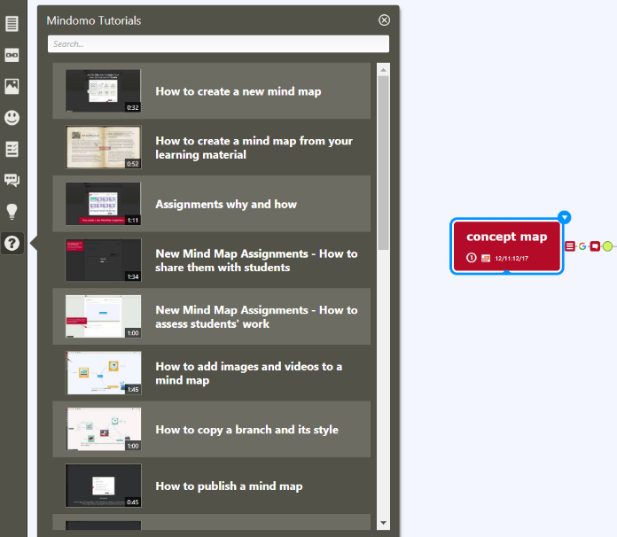
- You can look for Mindomo Tutorials

3.4 Download
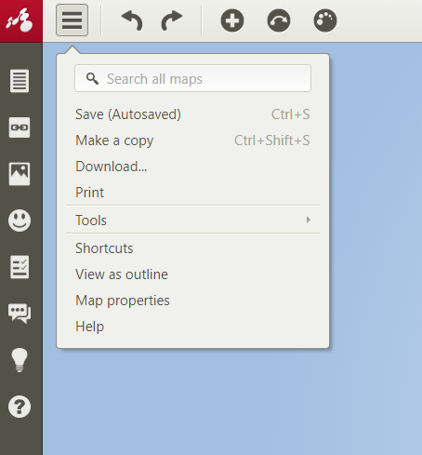
You can download your created concept map

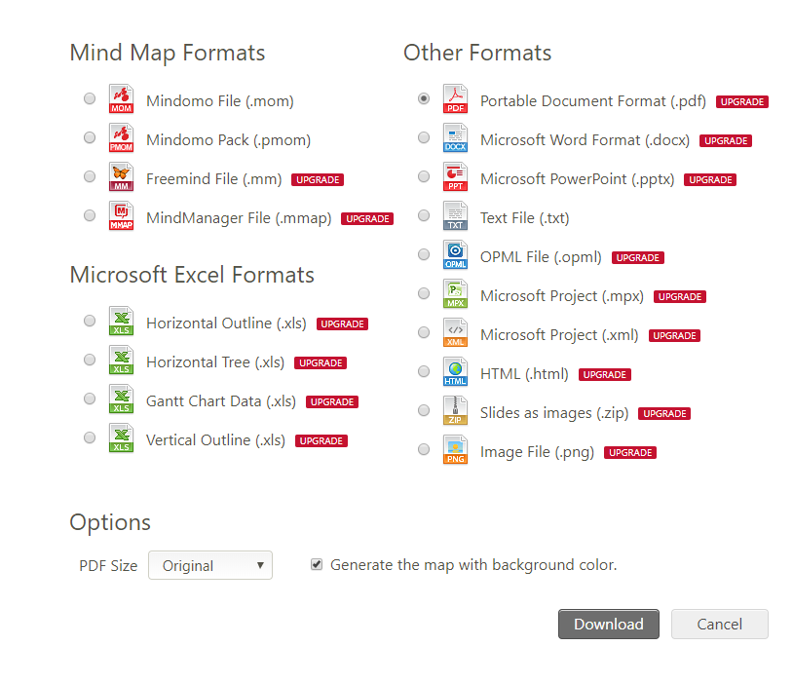
Note: Some formats are only available for premium users

4) License conditions
There are three types of licenses and you have a 30 days return guarantee. If you cancel within 30 days and are not completely satisfied, you will get your money back.

4.1 Desktop License overview
 | Desktop License Free | Desktop-Premium License
Available on all plattforms (Windows, OS X und Linux)
Mind Mapping and Concept Mapping
Task Management with Mind Maps
Number of topics in a map | 40 | unlimited
Import from .mmap, .mm, .mind, .xmind, .xml, .opml, and .txt
Export in .mmap, .mm, .pdf, .docx, .pptx, .txt, .opml, .zip, .png, .xls
Share maps with attached files

Search for pictures and videos on the internet * | X | 1 year
Support and Updates * | X

*Desktop Premium includes free updates and support for one year, as well as the ability to search images on the internet.
The Desktop Premium license gives you one year of free access to updates and support. After the first year, you can update it at any time if you need support and the latest version of the app.

4.2 Online License overview
https://www.mindomo.com/compare-educational.htm

5) Technical requirements
Mindomo is available on all plattforms: Windows, MAC OS X and Linux

