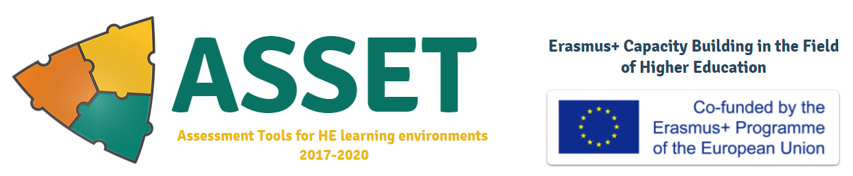
GE Final 3rdNational meeting
SCHEDULE
September 17-19 2020
Venue: Akhaltsikhe,
SamtskheJavakheti State University
122 Rustaveli street, Akhaltsikhe
Assessment Tools for new learning environments in higher education institutions
ASSET Project number 585587-EPP-1-2017-1-IL-EPPKA2-CBHE-JP

1st Day- 17 of September, 2020
13:30-14:15 | Gathering/reception/Opening remarks/Presentation of the Agenda | Tina Gelashvili, Inst. Manager of ASSET at SJSU
14:15 – 14:45 | Presentation of the Outcomes of Pilots of the Formative Assessment Tools, and their Implementation at TSU | Presentation by Izabela Petriashvili, TSU
14:45 – 15:15 | Presentation of the Outcomes of Pilots of the Formative Assessment Tools, and their Implementation at ISU | Presentation by SofikoLobzhanidze, ISU
15:15 – 16:00 | Coffee break
16:30 – 17:00 | Presentation of the Outcomes of Pilots of the Formative Assessment Tools, and their Implementation at SSU | Presentation by Lia Akhaladze, SSU
17.00-17.30 | Summing up of the 1st working day | All partners
 | 2nd Day-18 of September, 2020
10:00 – 10:30 | Presentations of the Georgian Translations of the Handbooks:  - Handbook on “Critical friends’ Approach” | Presentation by SofikoLobzhanidze, ISU; EkaTqavashvili, ISU
10.30 – 11.00 | - Handbook on “Open Digital Badges” | Presentation by Izabela Petriashvili, TSU;  Lia Akhaladze and Levan Kvaratskhelia, SSU; Diana Mikeladze, SJSU;
11:00 – 12:30 | - Handbook on „Group (peer) Assessment“ | Presentation by Gulnara Janova, SJSU;  Mariam Gognelashvili, TSU
12.30 – 12.00 | Coffee Break
12:00- 12:30 | - Handbook on „Soft Skills Assessment “ | Presentation by Tina Gelashvili, SJSU; Marika Kirvalidze ISU; Nino Chikovani, TSU; Levan Kvaratskhelia SSU;
12:30 – 13:00 | - Handbook on “Group Reflective Diary” | Presentation by MakaMurvanidze SJSU; Tamar Sinjiashvili, Omar Ardashelia, SSU
13.00 – 13.30 | - Handbook on “Concept Maps (CoMA)” | Presentation by Levan Kvaratskhelia, Nino Tsulaia, SSU; Ina Baratashvili TSU
13.30 – 14.30 | Lunch
14.30-15.00 – TSU  15.00-15.30 – SJSU  15.30-16.00 – SSU  16.00-16.15 - TPDC | Separate meetings with each partner HEI manager: Revision of expenditures presented in the Financial Statements | Manana Salukvadze, ISU  All Inst. Managers
16.15-16.30 | Summing up of the2ndworking day
 | 3rd Day 19 of September, 2020
10:00-11:30 | Dissemination activities in each university | Facilitation by Marika Sikharulidze
11:30-12:00 | Coffee Break
12:00 – 13:30 | Final Financial overview; | Facilitation by Manana Salukvadze
13.30 – 14.30 | Lunch
14:30-15:30 | Preparation for submission of the Final Report  Working on the Final Reporting e-system and review of the roles | KetevanDarakhvelidze, Head of Development office Ilia State University(ISU)
15.30-16.00 | Summing up the final National Meeting | ALL Partners Institutions

